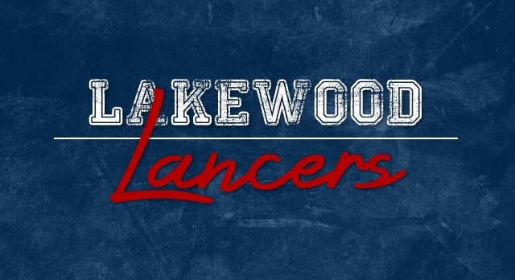
2016 – 2017 Volunteer Opportunities

Interested in getting involved in what’s going on, but you’re not sure how? Whether you have 5 hours a week or 2 hours to volunteer for the entire year, we’d love for you to get involved. The list below is a great place to start. Sign up tonight in the cafeteria.

Topic | Description | Timing | Contact
Parent/Community Groups
Lakewood Education Foundation | Non-profit group that supports students in career and college readiness. | Monthly meetings & school event support | Cassie Kane ckane@kanelearning.com
PFO | Parent & Faculty Organization |  | Sherrie Poling sherriepoling@gmail.com
Get On Track | Career and College Readiness support at the High School – resource room staffed by volunteers. | During the school day | Holly Graham  hgraham@harttech.com
Academics
Career Event | 6th grade event that allows students to learn about a variety of careers – new event this year – need help planning, preparing and executing | Monthly planning meeting and event day during school | Julia Raymond  jmraymond@laca.org
Project Based Learning | Creating and supporting projects that help students learn classroom content in a deeper way | During the school day | Jessica Fry  jfry@laca.org
Reality Store Event | Event where 7th and 8th graders learn the “true cost of living” by making budget choices based on an assigned career, salary, etc. | ½ day in May | Cassie Kane  ckane@kanelearning.com
Reality Store Classroom Sessions | 2 classes students attend prior to the event. Requires strong facilitation skills and some preparation. | 2 – ½ days in May | Cassie Kane  ckane@kanelearning.com
STAR (formerly Academic Assist) | Learning centers that develop critical thinking, application of knowledge and problem solving skills. | During the school day | Jeanine Fairburn  rfairburn@laca.org
STAR Reading | Reading 1:1 or 1:2 with students | 7th or 8th periods | Jeanine Fairburn rfairburn@laca.org
Titanic Unit | Expert in Titanic or large boats to connect with students | 2nd 9 weeks, during school | Melisa Hatem  mhatem@laca.org
Tutoring | Working with students who need support in a particular subject | After school | Julia Raymond  jmraymond@laca.org
STEM (Science, Technology, Engineering, Math)
Future City | STEM competition | Sept – Jan Wed after school – 4:30 | Pamela Hundley  phundley@laca.org
Robotics |  |  | Dawn Villares  dvillares@laca.org
Science Fair | 6th grade science fair preparation, planning, etc. |  | Debbie Coffey  dcoffey@laca.org
STEAM Team (Land Lab) |  | Sept – April Thurs after school – 4:30 | Lisa Hawthorn  lhawthorn@laca.org
Tech Challenge |  |  | Dawn Villares  dvillares@laca.org
Student Leadership
National Jr Honor Society | National Jr Honor Society | After school | Jeanine Fairburn rfairburn@laca.org
Student Council | Student government for all grades | After school 2nd Tuesday of each month | Pamela Hundley  phundley@laca.org
Art & Fine Arts
Art Club |  |  | Pam Swart  pswart@laca.org
Band |  |  | Rob Caldwell rmcaldwell@laca.org
Choir |  |  | Ryan Grubb rgrubb@laca.org
Drama |  |  | Martha Fickle  mfickle@laca.org
Athletics
Athletics |  |  | Rex Sponhaltz  rsponhaltz@laca.org

